**Curve**

Curve代表曲线，我们知道模型是由几何体和材质构成，那么Curve如何生成模型呢？

    // 生成一条曲线

    var curve = new THREE.ArcCurve(0, 0, 100, 0, 2 * Math.PI, true);

    // 获取曲线的顶点，50表示将曲线分成50端，返回这些顶点信息

    var points = curve.getPoints(50);

    // 生成几何体

    var geometry = new THREE.BufferGeometry();

    // 设置几何体顶点

    geometry.setFromPoints(points);

    // 材质

    var material = new THREE.LineBasicMaterial({

        color: 0xff0000

    });

    // 模型

    var line = new THREE.Line(geometry, material);

- getPoints(divisions)

获取曲线的顶点，可传入参数divisions，表示将曲线分成几段

- setFromPoints

设置几何体的顶点信息

**曲线类型**

1. 直线

// 三维直线LineCurve3

var p1 = new THREE.Vector3(50, 0, 0); //顶点1坐标

var p2 = new THREE.Vector3(0, 70, 0); //顶点2坐标

var LineCurve = new THREE.LineCurve3(p1, p2);

// 二维直线LineCurve

var LineCurve = new THREE.LineCurve(new THREE.Vector2(50, 0), new THREE.Vector2(0, 70));

1. 圆弧线

new THREE.ArcCurve(aX: number, aY: number, aRadius: number, aStartAngle: number, aEndAngle: number, aClockwise: boolean)

1. 样条曲线

样条曲线是一条经过多个顶点的曲线，我们需要给出顶点信息

    var curve = new THREE.CatmullRomCurve3([

        new THREE.Vector3(-50, 20, 90),

        new THREE.Vector3(-10, 40, 40),

        new THREE.Vector3(0, 0, 0),

        new THREE.Vector3(60, -60, 0),

        new THREE.Vector3(70, 0, 80)

    ]);

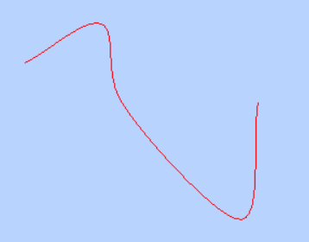

**组合曲线CurvePath**

组合曲线可以把多个曲线组合在一起

    var R = 80;//圆弧半径

    var arc = new THREE.ArcCurve(0, 0, R, 0, Math.PI, true);

    var line1 = new THREE.LineCurve(new THREE.Vector2(R, 200), new THREE.Vector2(R, 0));

    var line2 = new THREE.LineCurve(new THREE.Vector2(-R, 0), new THREE.Vector2(-R, 200));

    // 创建组合曲线对象CurvePath

    var curve = new THREE.CurvePath<THREE.Vector2>();

    // 把多个线条插入到CurvePath中

    curve.curves.push(line1, arc, line2);

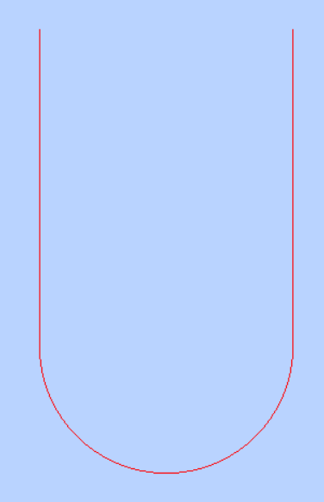

**管道几何体TubeGeometry**

TubeGeometry接受一个曲线参数，生成一个管道几何体

    // 生成一条曲线

    var curve = new THREE.LineCurve3(new THREE.Vector3(200, 0, 0), new THREE.Vector3(0, 0, 0));

    // 生成几何体

    var geometry = new THREE.TubeGeometry(curve, 100, 5, 25, false);

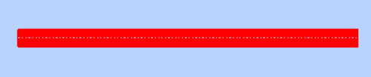

**旋转几何体LatheGeometry**

LatheGeometry接受顶点信息（一条曲线），这条线绕y轴旋转成一个几何体

    var points = [

        new THREE.Vector2(50,60),

        new THREE.Vector2(25,0),

        new THREE.Vector2(50,-60)

    ];

    var geometry = new THREE.LatheGeometry(points,30);

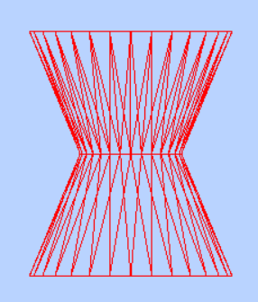

**拉伸几何体ExtrudeGeometry**

ExtrudeGeometry把一个平面沿曲线拉伸为一个3维物体

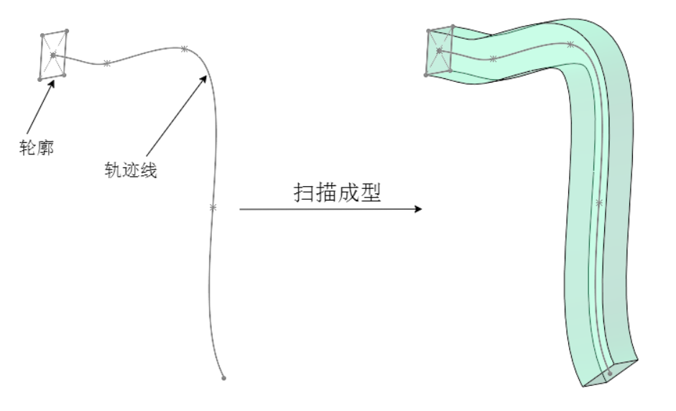

    var shape = new THREE.Shape();

    /**四条直线绘制一个矩形轮廓*/

    shape.moveTo(0, 0);//起点

    shape.lineTo(0, 100);//第2点

    shape.lineTo(100, 100);//第3点

    shape.lineTo(100, 0);//第4点

    shape.lineTo(0, 0);//第5点

    var geometry = new THREE.ExtrudeGeometry(//拉伸造型

        shape,//二维轮廓

        //拉伸参数

        {

            depth: 200,

            bevelEnabled: false//无倒角

        }

    );